Question 2 (20 Marks)

  - Consider the following Java program:

01 | //Program 1
02 | public enum Color {
03  04 | RED("FF0000"), GREEN("00FF00"), BLUE("0000FF");
05 | private String hexCode;
06
07 | private Color(String hexCode) {
08 | this.hexCode = hexCode;
09  10 | l
11 | public String getHexCode() {
12 | return hexCode;
13 | }
14 | public static void main(String [] args) {
15 | for (Color color = Color.values())
16 | System.out.println((color.ordinal() + 1) + ") " + color +
17 | " has code " + color.getHexCode());
18 | }
19  2 0 | l

Based on the program above that defines an enumerated type called Color, answer the following questions:
    - What is the significance of the values "FF0000", "00FF00", and "OOOOFF" that are passed as arguments to the constructor of each value in the Color enumerated type?
the color code of hexadecimal in RGB (Red, Green, Blue) html.

(1 mark)
    - What is the purpose of the getHexCode () method in the Color enumerated type?
to get the value color code of each enum Color

(1 mark)
    - What will be the output of the program?
1) RED has code FF0000
2) GREEN has code 00FF00
3) BLUE has code 0000FF
(3 marks)

    - Write a Java statement in main () method that uses the compareTo () method to display the results of a comparison of the positions of RED and BLUE in the Color enumerated type. What will the output be?
System.out.println(Color.RED.compareTo(Color.BLUE));

Output:
-2
(2 marks)

    - Consider adding the following statements in the main () method:
if (Color.GREEN.equals(Color.RED))
System.out.println("GREEN and RED are two different colors."); else
System.out.println("GREEN and RED are the same color.");

The statements, however, include an error. What is the error, and how can it be fixed?

it should be, if (!Color.GREEN.equals(Color.RED))
(2 marks)

  - Given the directory structure as shown below:

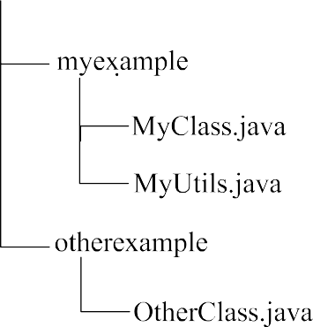
    - What is the package name of Myclass.java and MyUtils.java?
com.myexample

    - What is the package name of OtherClass.java?
com.otherexample

(1 mark)

(1 mark)

    - In TestApp.java, how would you import all the classes in com. myexample?
import com.myexample.*;
(1 mark)
    - Suppose you want to move MyUtils.java to a new package called com. myexample.util. What changes would you need to make to the directory structure and the code?
project/com/myexample/util
(3 marks)

  - Consider the Java program below and answer the following questions:

01 | //Program 2
02 | public class WrapperClass {
03 | public static void main(String[] args) (
04 | Integer numl = 10;
05 | Double num2 = 3.14;
06
07 | //(a)Converting an object of a wrapper type to
08 | //its corresponding primitive value
09 | int value1 = num1.intValue() ;
10 | double value2 = num2.doubleValue() ;
11
12 | System.out.println(“valuel: “+ valuel);
13 | System.out.println(“value2: “+ value2);
14
15 | //(b)Adding valuel and value2 and storing the
16 | //result in the result variable by converting
17 | //it to the Double wrapper class
18 | Double result = Double.valueOf(value1 + value2 );
19
20 | System.out.println(“result: ”+ result);
21 | }
22 | }
    - Fill in the blanks with an appropriate Java statement to convert an object of a wrapper type to its corresponding primitive value. Note: you must use a method provided in the wrapper class. What is the name of the conversion?
Unboxing

(3 marks)
    - Fill in the blanks with an appropriate Java statement to add valuel and value2 and store the result in the result variable by converting it to the Double wrapper class. Note: you must use a method provided in the wrapper class.
(2 marks)

